1. Successful Login
- Email + password entered
- User redirected to dashboard / account page
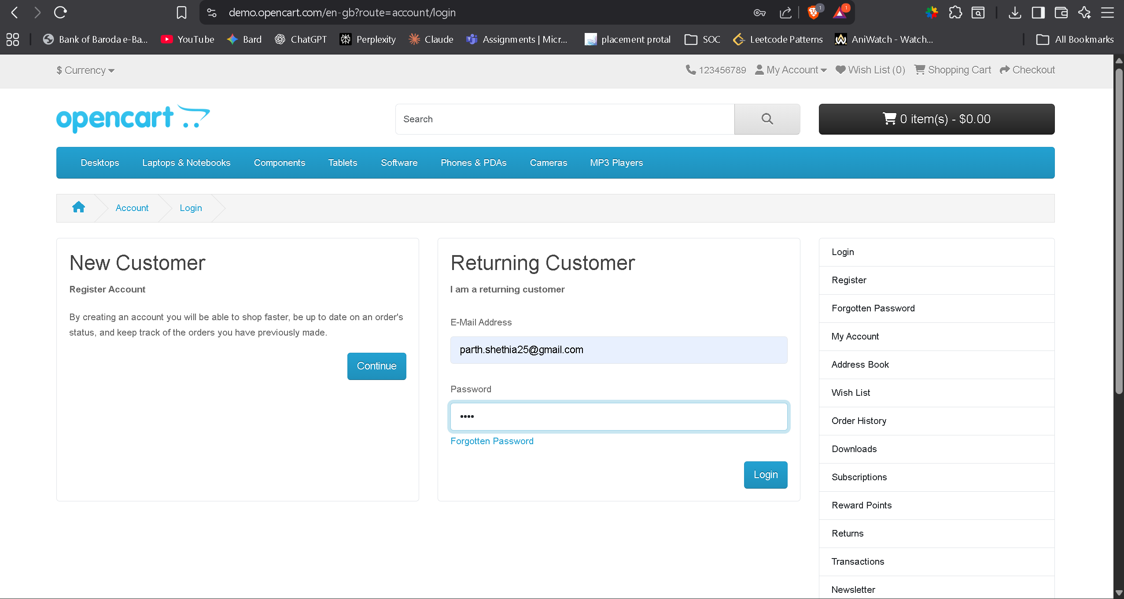
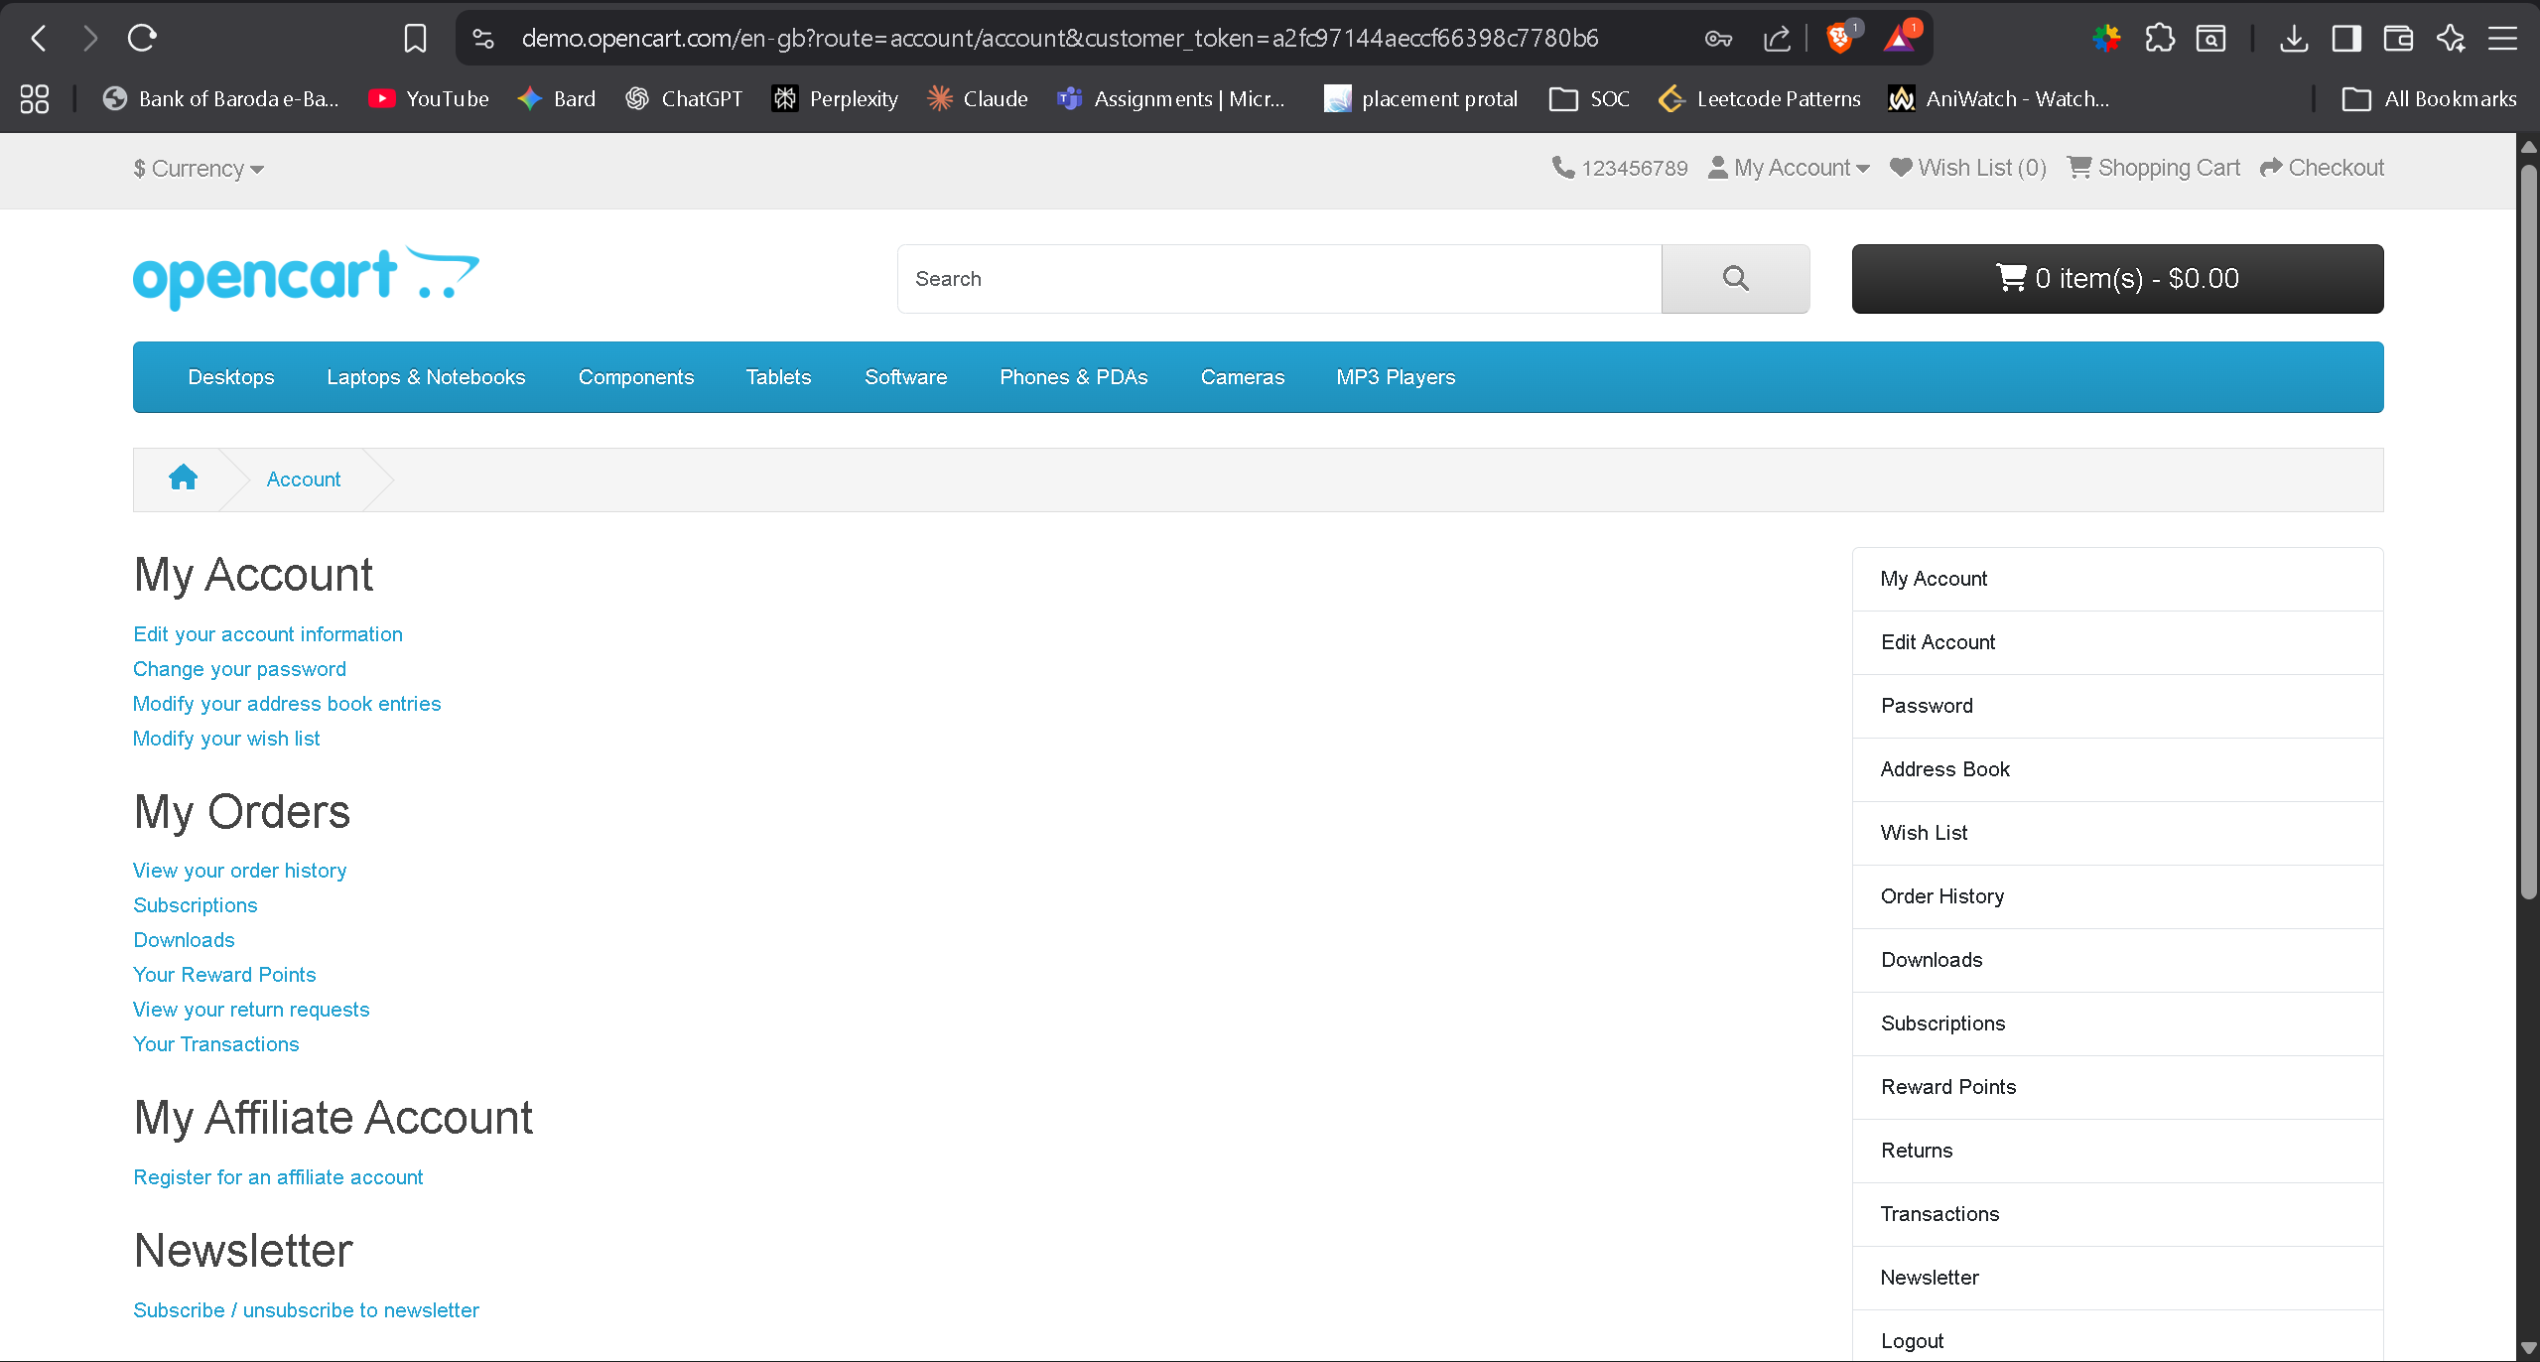
2. Successful User Registration
- Confirmation message like “Your account has been created!”
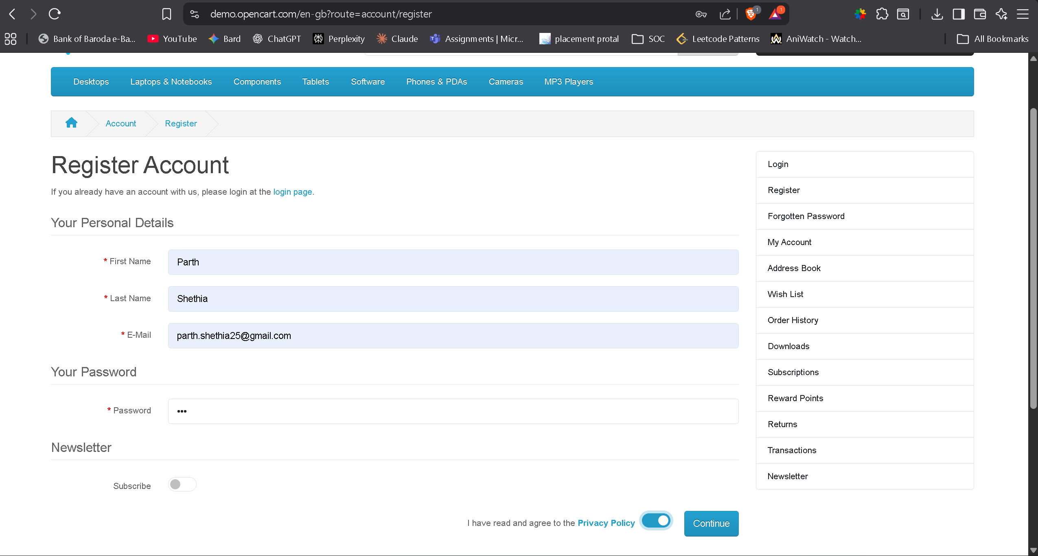
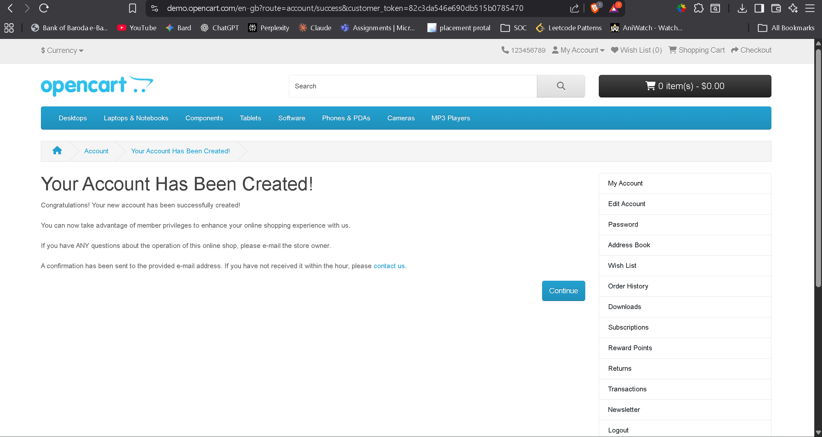
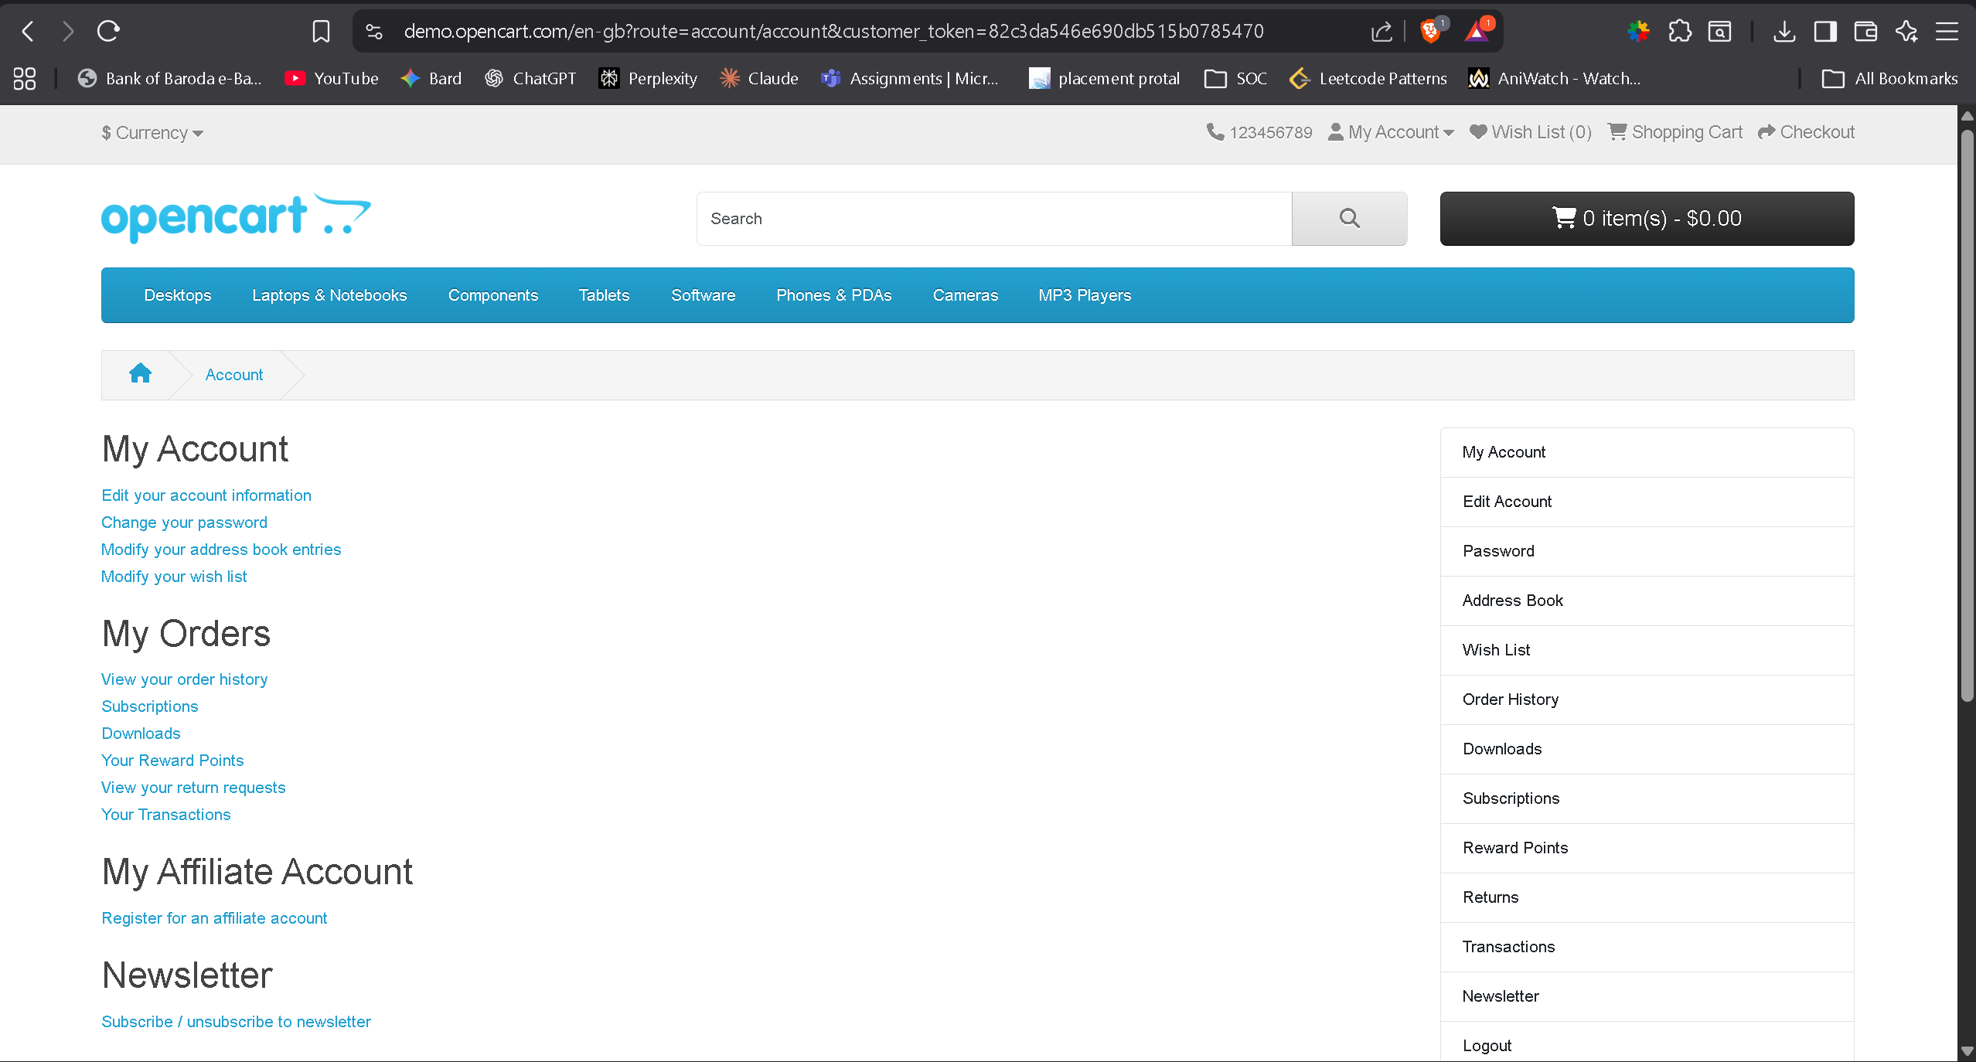
3. Product Listing Page Loaded
- Products visible
- Category menu loaded correctly
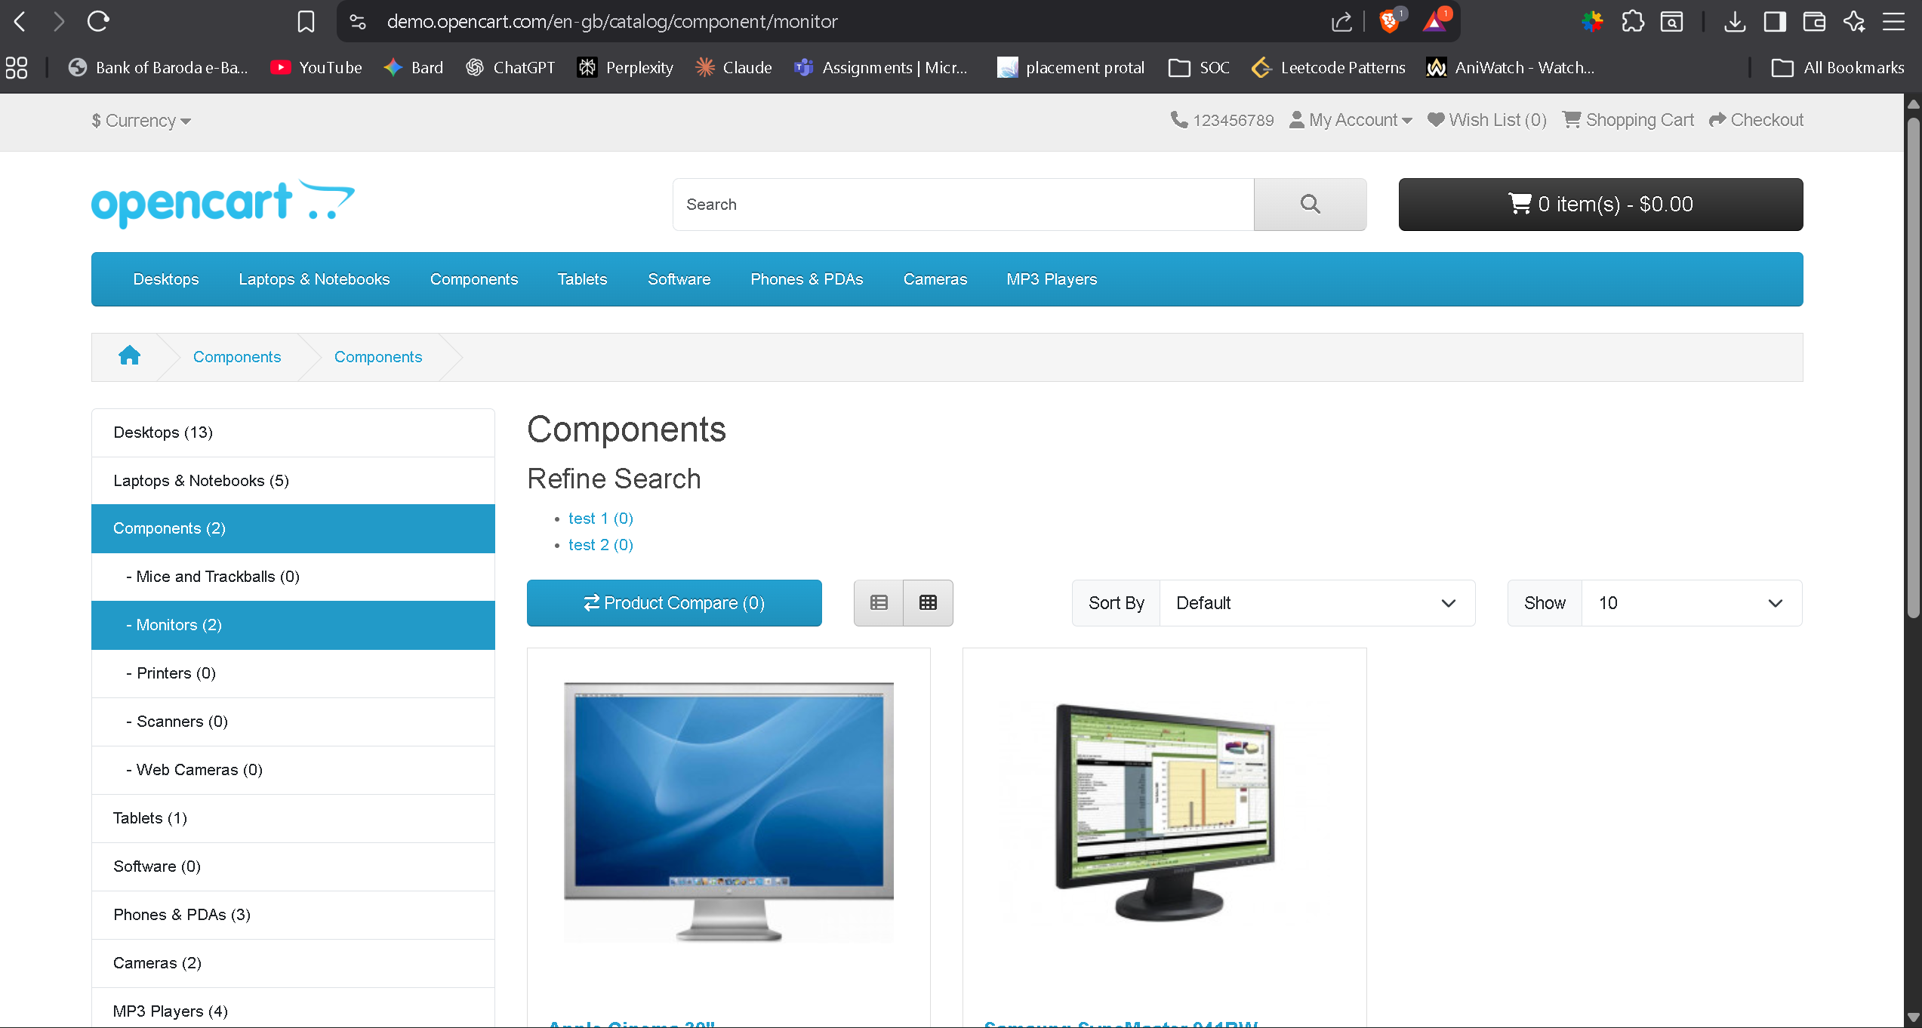
4. Search With Valid Keyword
- Search “Mac” showing multiple results
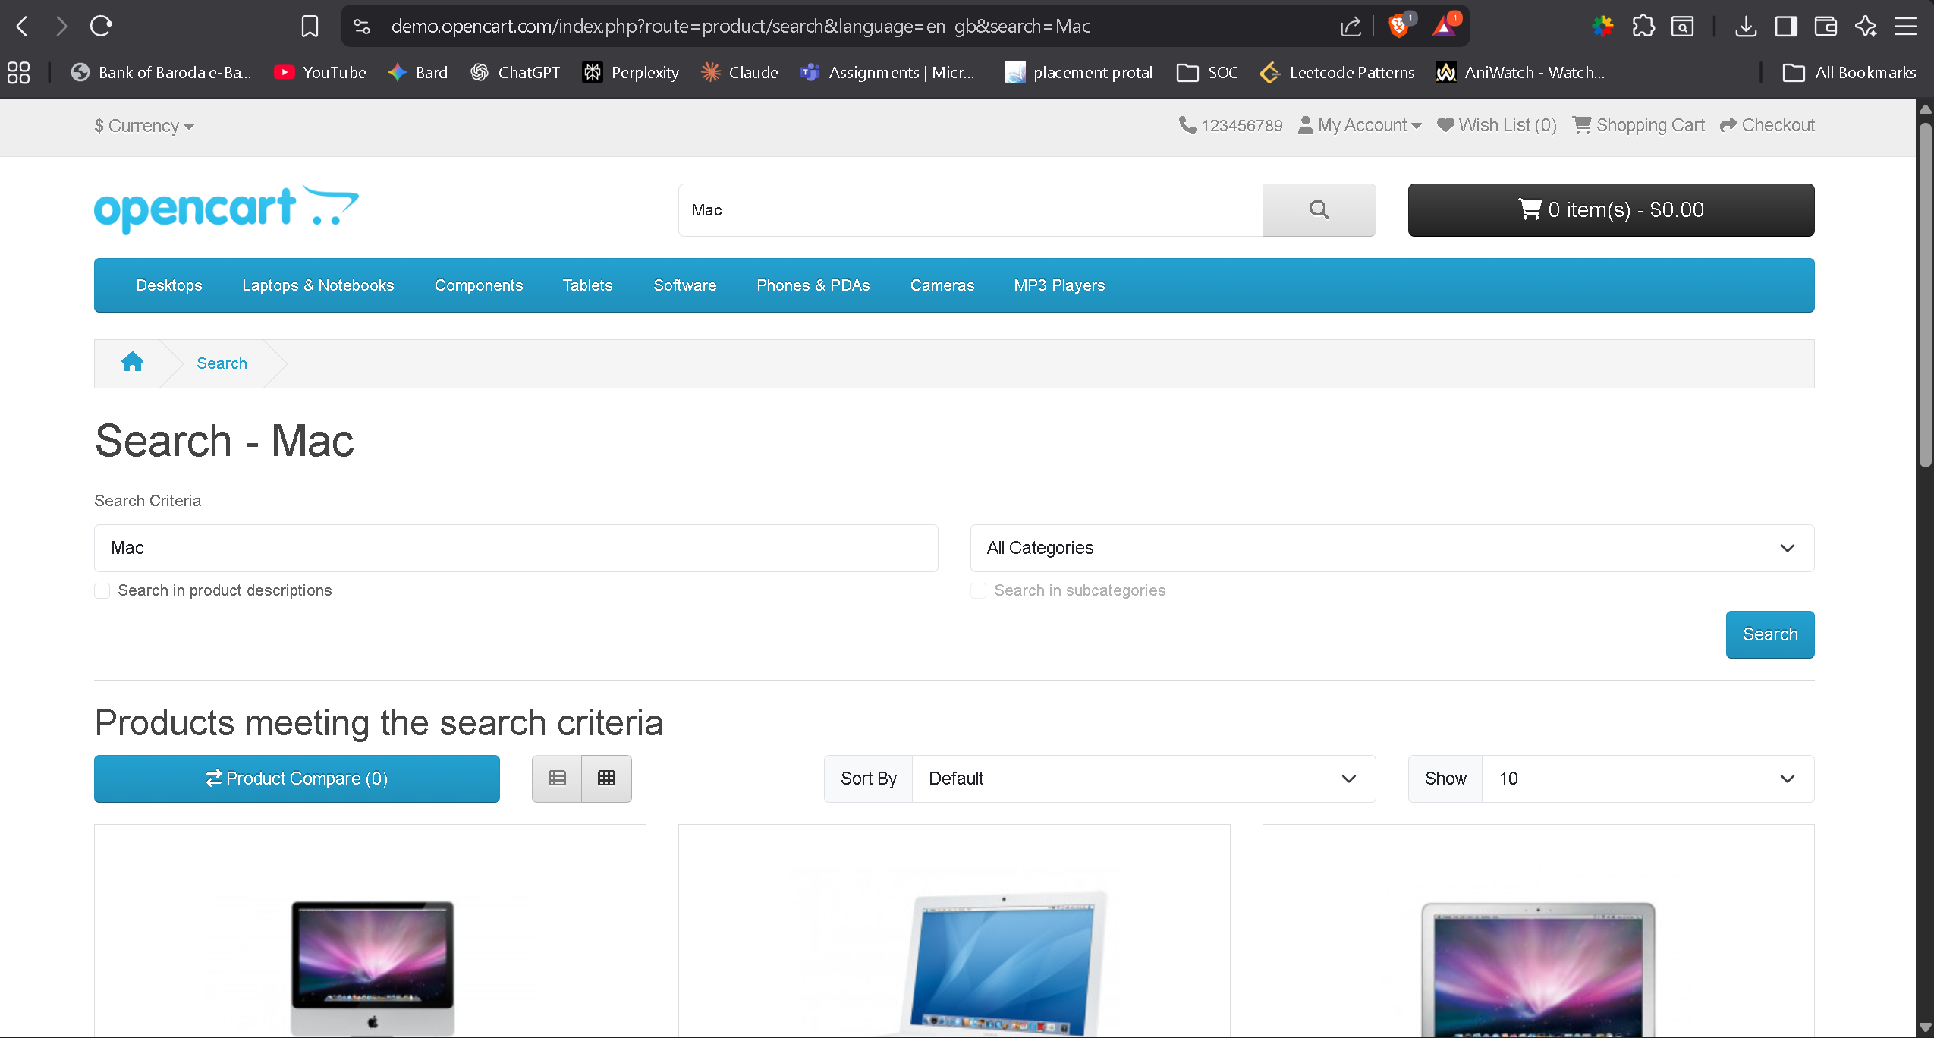
5. Product Details Page
- Image, description, and price displayed correctly
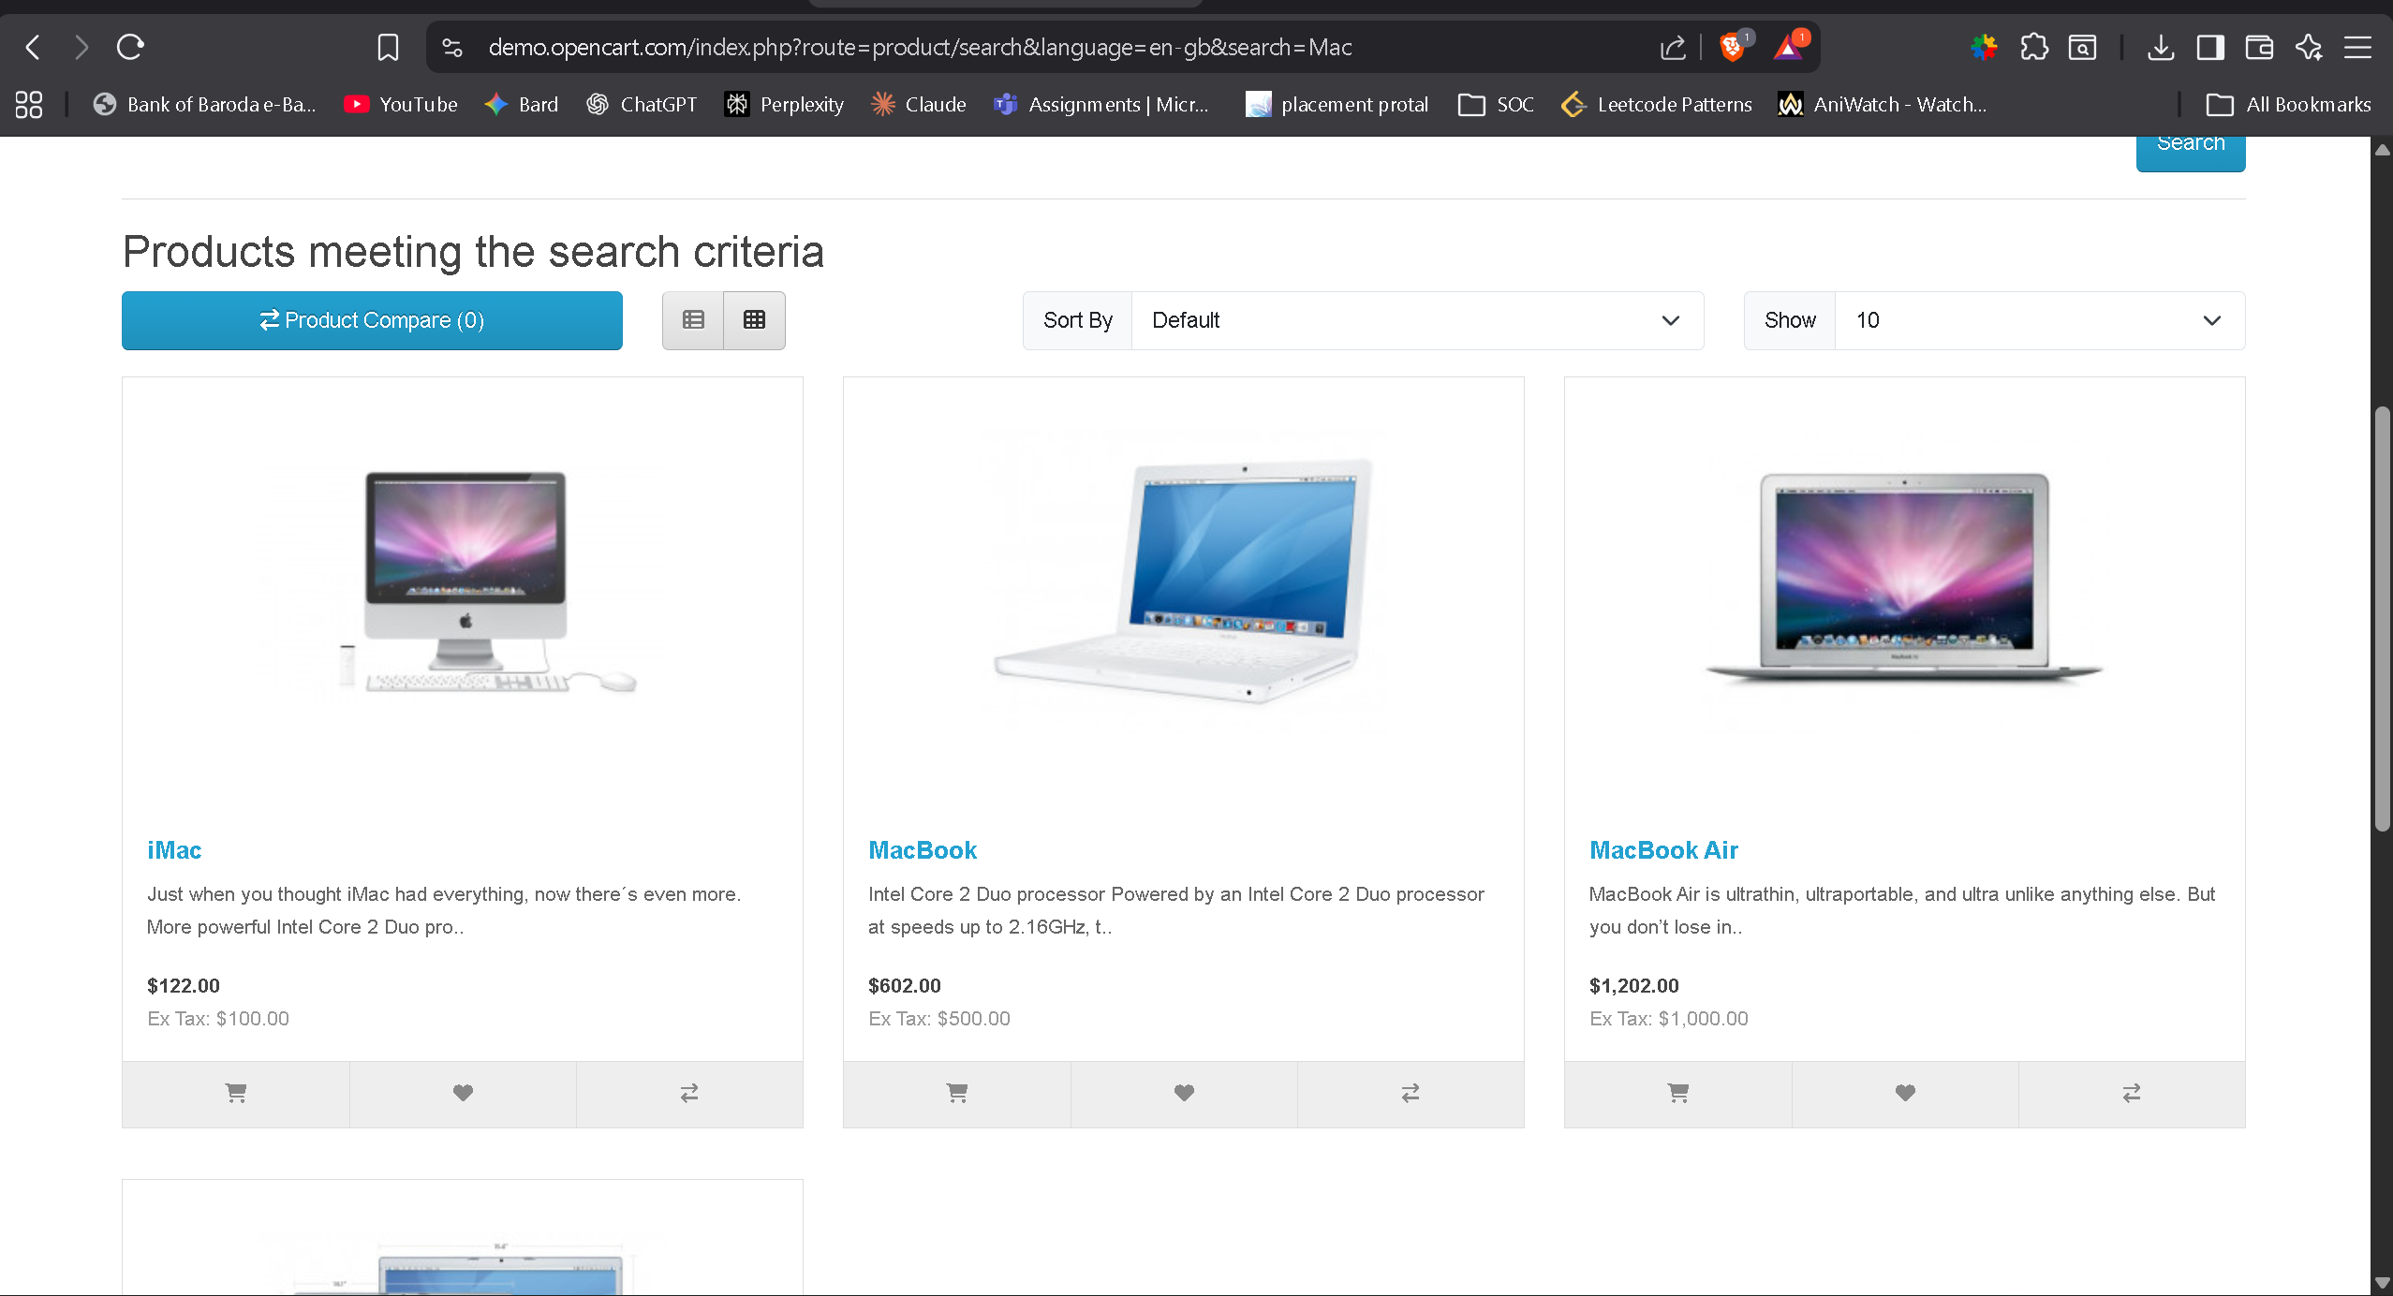
6. Product Added to Cart
- Cart icon updated
- “Success: Item added to cart” message
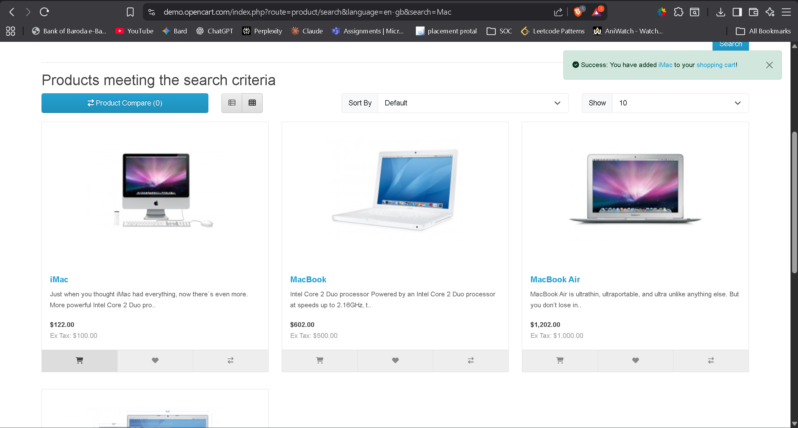

7. Cart Page — Correct Totals
- Quantity × price = correct amount
- Subtotal correct
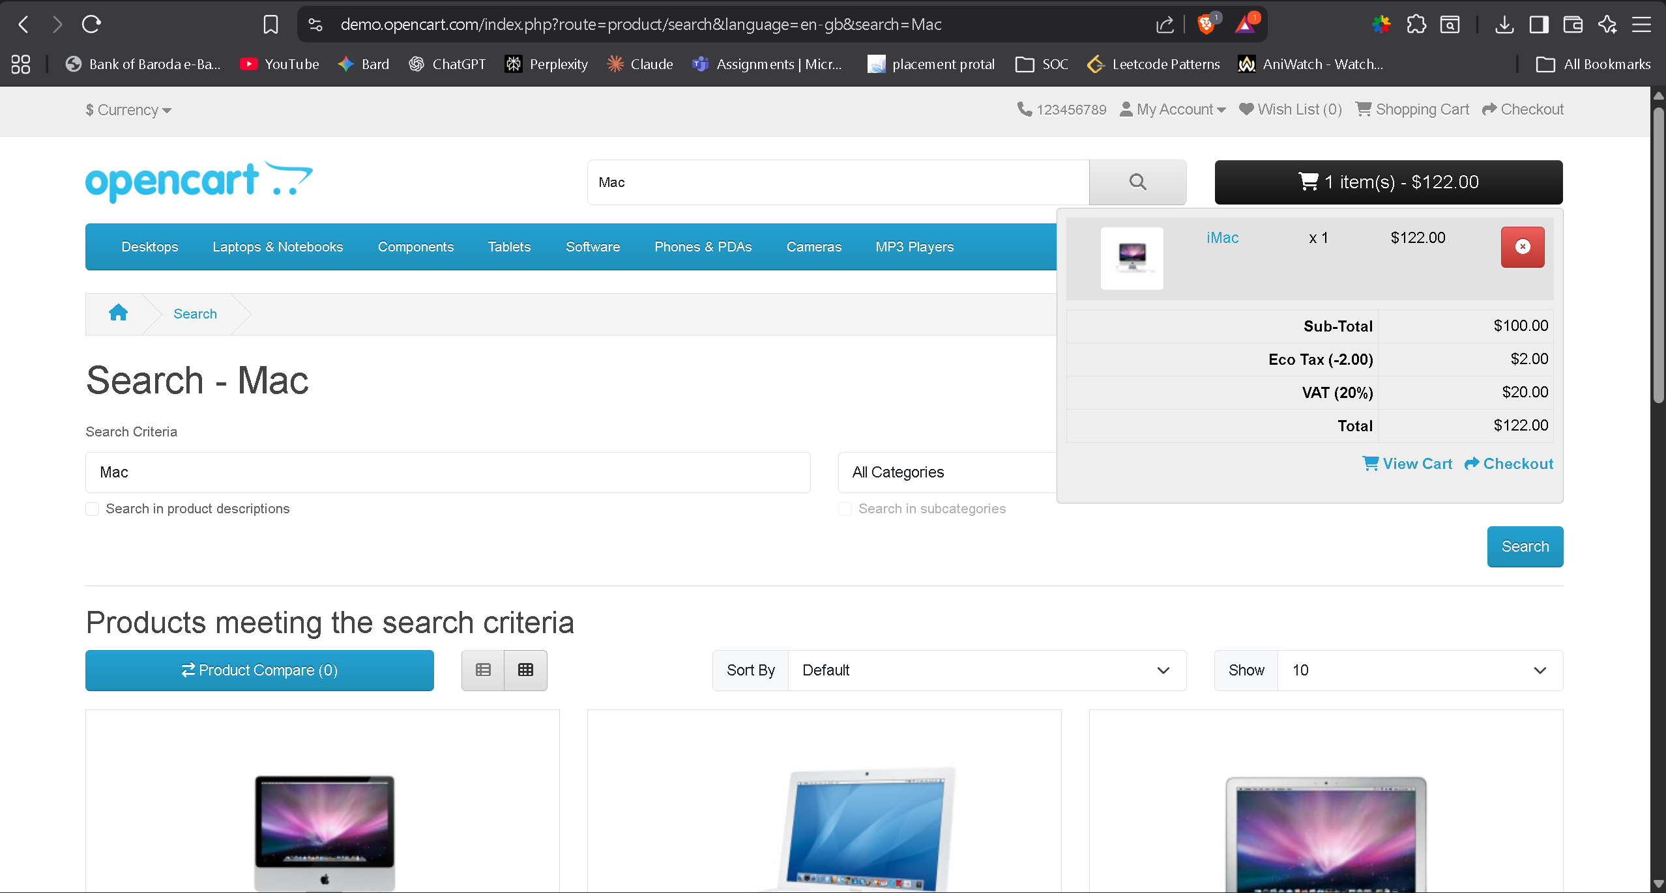
8. Checkout Page Loaded Properly
- Payment options visible
